Report: Proposed Reclassification and Rezoning of Oliver Street Carpark and Lawrence Street Carpark, Freshwater

Executive Summary
Freshwater Village is a local centre comprising a number of local retail and community uses along Lawrence Street, Freshwater. There are two Council-owned carparks positioned behind the shops; one with access from Oliver Street and the other with access from Lawrence Street. There is one-way vehicular access from the Lawrence Street carpark to the Oliver Street carpark. An Ausgrid owned substation divides the carparks.
Under the Local Government Act 1993, public land must be classified either Community Land or Operational Land. Community land can only be used for public purposes and is usually associated with open space e.g. public parks. Council cannot sell community land or grant a lease, license or other estate for private purposes over community land. Operational land can be used by Council for commercial purposes and can be leased or sold by Council.
Both carparks are currently classified Community Land.
This means that shop owners on Lawrence Street are not authorised to use the carparks to gain access to their properties e.g. for loading and unloading or for on-site parking and must provide vehicular access to their properties directly from Lawrence Street.
The proposed change in classification of the carparks from Community land to Operational land would:
- permit owners of shops fronting Lawrence Street to obtain legal access to their land from Council’s carparks for unloading and parking; and,
- enable the gradual removal of driveway crossings on Lawrence Street as the shops are redeveloped with vehicular access from the carparks, improving pedestrian safety and amenity on Lawrence Street.
The carparks are currently zoned for RE1 - Public Recreation. The carparks have no current recreational or open space value. Re-zoning to B2 – Local Centre would better reflect the current use and purpose for which the space is used and match the adjacent land zonings surrounding the carparks.
Council has no plans to develop or sell the carparks. While the rezoning would permit additional uses, Council is aware that the carparks are needed by the community.

Introduction
The Council-owned Oliver Street and Lawrence Street carparks in Freshwater Village provide car parking for local residents visiting the centre.
The current classification of these carparks under the Local Government Act, 1993 as “Community” land prevents Council from granting a lease or a licence to Lawrence Street land owners for vehicular access to their properties.
As a consequence, Lawrence Street land owners are either obtaining vehicular access from these carparks without authorisation or are obtaining vehicular access to their properties directly from Lawrence Street via a number of driveway crossings.
The reclassification of the carparks from “Community” to “Operational” land would:
- permit owners of shops fronting Lawrence Street to obtain legal access to their land from Council’s carparks for unloading and parking etc.
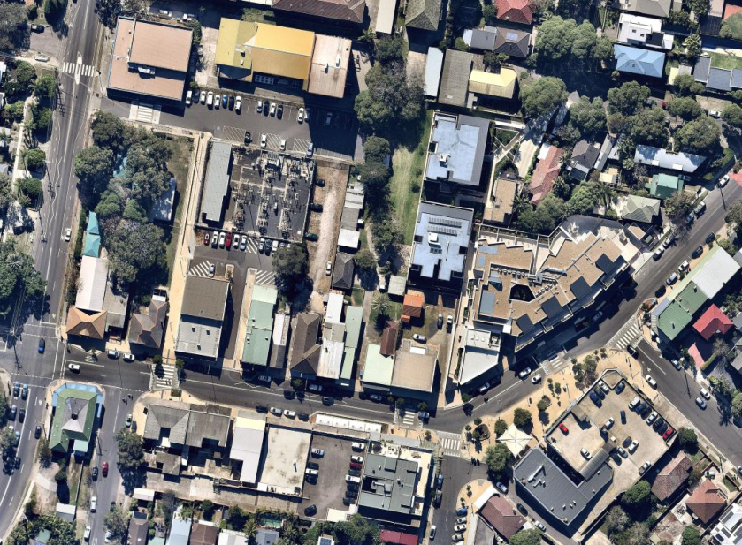
- enable the gradual removal of driveway crossings on Lawrence Street as the shops are redeveloped with vehicular access from the carparks, improving pedestrian safety and amenity on Lawrence Street.
At the time of writing, Council is considering a development application for the redevelopment of 21 Lawrence Street, Freshwater and a development application has recently been approved for 9-15 Lawrence Street.
DA 2017/1287 proposes construction of shop-top housing at 21 Lawrence Street. Vehicular access to the property is currently via a driveway crossing from Lawrence Street. The development application proposes to maintain that crossing. The rear of the site adjoins the Oliver Street carpark.
DA 2017/1294 approved construction of shop top housing at 9-15 Lawrence Street. Vehicular access to the property is currently via a driveway crossing from Lawrence Street. The development application proposes to maintain that crossing. The north-western boundary of the site adjoins the Oliver Street carpark.
It would be possible to provide vehicular access to both of these sites from the Oliver Street carpark and remove the current driveway crossings in Lawrence Street if the carpark was reclassified as “Operational” land under the Local Government Act 1993.
Properties at 21, 23, 25 and 27 Lawrence Street currently also obtain unauthorised rear vehicular access from Council’s Lawrence Street carpark. Without reclassification of this carpark Council has no obligation to maintain this arrangement in the future.
Council has previously proposed the reclassification and rezoning of these carparks (from RE1 - Public Recreation to B2 – Local Centre) however did not proceed with these proposals due to concerns expressed by the community about the potential sale of the carparks: The reclassification of the carparks to “Operational” land would permit their lease, licence or sale by Council.
At its meeting in March 2014, Council resolved to rezone a number of carparks in the Council area from Public Recreation to business zones and prepare planning reports to consult with the community about potential reclassification of the carparks to better reflect surrounding land uses. The Oliver Street and Lawrence Street carparks were included in the resolution. Since that time, Council has been working through the rezoning and reclassification proposals (e.g. the Forestville local centre carpark, which was reclassified in 2016) and has been exploring options to address the concerns of the community about the proposed reclassification.

Purpose of the Report
This report outlines the current land use planning controls for the area, summarises the history of the proposed reclassification and rezoning of the carparks, and describes the process by which reclassification and rezoning could occur.
Comments received during the public exhibition of this report will be included in a report to Council for its consideration to determine whether to proceed with the reclassification/ rezoning.
History of Classification of Oliver Street and Lawrence Street Carparks
With the commencement of the Local Government Act, 1993, Councils had 12 months to classify public land. Council owned land not classified within 12 months of the implementation of the Local Government Act was automatically classified Community Land. A number of carparks, including Oliver Street and Lawrence Street carparks, were classified Community Land. A series of resolutions about the carparks by the former Warringah Council followed:

- 24 May 1994 - a Council resolution to give public notice of its intention to reclassify both Oliver Street and Lawrence Street carparks to Operational Land. Proposed reclassification was exhibited for 28 days.
- 28 June 1994 - Council considered a report on the public exhibition and resolved to classify parcels of Council owned land, including Oliver Street and Lawrence Street Carparks, as Operational.
- 9 December 1997 - a report was put to Council after advice received from the Department of Local Government questioning the validity of the process of land classification undertaken by Council in 1994. Council resolved to undertake consultation as part of the reclassification process.
- 22 February 2000 – a report to Council recommended reclassification of land to Operational in accordance with a report prepared by an external consultant. Council resolved not to pursue due to community concerns expressed at the time about the potential sale of a community asset.
- 14 July 2009 - a report went to Council seeking to reclassify and rezone the Oliver Street Carpark. Council resolved to undertake community consultation, including a resident information session.
- 24 November 2009 - Council resolved to establish a Freshwater Village Working Party (FVWP) to consider issues relating to planning and reclassification of the carparks. The FVWP would report back to Council to make recommendations. First meeting of FVWP in February 2010.
- 27 April 2010 – Report to Council recommending reclassification of carparks. A Notice of Motion was carried requiring further consultation with FVWP before rezoning and reclassification considered.
- 22 June 2010 – Council resolved to engage independent consultants to prepare a site specific DCP for Freshwater Village.
- 22 February 2011 – Council resolved to defer work on DCP until Land and Environment Court decision received regarding development on 8 lots in Village, involving 91 units.
- 26 July 2011 – Council considered a request from FVWP to fund feasibility assessment of a new road from Oliver Street to Moore Road through the Oliver Street Carpark and 7 private properties. No resolution was made on the matter.
- 14 February 2012 - Council resolved to place the Freshwater Village DCP on public exhibition.
- 22 May 2012 - Council resolved to adopt the Freshwater Village DCP.
- 25 March 2014 - Council resolved to rezone a number of carparks in the Council area from Public Recreation to business zones and prepare planning reports to consult with the community about potential reclassification of a number of carparks including the Oliver and Lawrence Street Carparks to Operational land and to rezone these carparks to reflect the surrounding land use.
This report is intended to fulfil the March 2014 resolution.
Locality and Site Context
Freshwater Village is located within the south east portion of the Northern Beaches Local Government Area (LGA). Freshwater is identified as a small village within the LGA, having an approximate area of 27,000m², excluding roads (Figure 1).
The village provides a range of small scale retail and commercial functions. The Freshwater village generally services the day to day needs of surrounding residents and a small localised catchment. Freshwater Village is characterised by a mix of small scale, two storey retail and commercial businesses, generally containing shop top housing interspersed with more recent larger scale two and three storey retail, commercial and apartment mixed use developments.

Freshwater Beach Beach
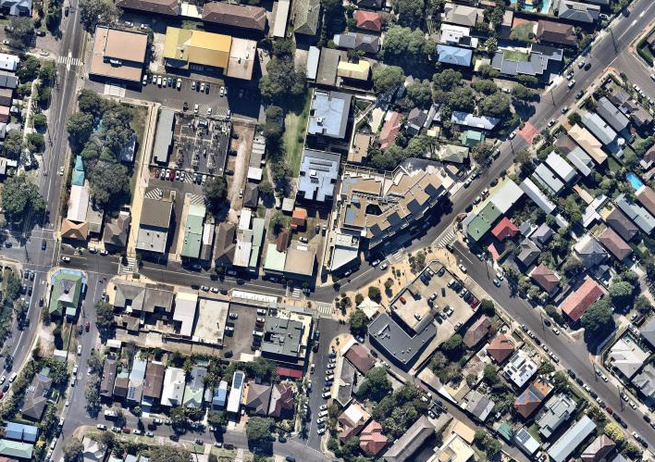Figure 1 – Freshwater Village Locality
Brookvale /
Dee Why

Freshwater Village
27,000m²
Sydney CBD
Land Use Controls
Local Government Act 1993
The Local Government Act 1993 (LG Act) identifies the requirements for all Council owned land as well as for Plans of Management. The LG Act introduced the classifications of ‘Community’ and ‘Operational’ land and requires all land under Council ownership to be classified as either ‘Community’ or ‘Operational.’ The LG Act requires that the use and management of ‘Community Land’ be regulated by a Plan of Management. Section 46 of the LG Act does not permit Council to grant a lease, license or other estate for private purposes or interests over land classified ‘Community Land – General Community Use.’
As such, Council cannot permit access to private property where that access is gained across land classified as ‘Community.’ Council may only grant uses for public purposes, uses undertaken in accordance with the core objectives of the category ‘Community Land – General Community Use’, for a short-term casual purpose or for filming.

Classification
Oliver Street carpark and Lawrence Street carpark are classified Community Land under the Local Government Act 1993. The classification prohibits access to private land and requires a Plan of Management (PoM) to manage the land. Community Land is better associated with open space i.e. parks. Community Land is inconsistent with the current use of the land as a carpark. Operational Land would permit legal access to the adjoining properties, which would comply with the requirements of the Freshwater Village Development Control Plan 2011 (see separate section) and resolve the urban design issues along Lawrence Street. A recent reclassification of a carpark from community land to operational land is in the Forestville local centre Darley Street carpark and Starkey Street carpark.

Plan of Management
The land and surrounds (including the Harbord Literary Institute, Early Childhood Health Centre and pedestrian access way) are covered by the Harbord Literary Institute and Early Childhood Health Centre Plan of Management (PoM) which was adopted by Council on 25 March 2008. The PoM provides the framework for managing the use of land and the community facilities to which it applies. In general, the PoM governs what can and what cannot be undertaken on land to which it applies.

The land is currently classified as ‘Community’ land – ‘General Community Use’ under the PoM as defined by the Local Government Act 1993 (LG Act). The PoM is generally silent on the Oliver Street and Lawrence Street carparks, with the exception of references to proposed works (pedestrian/vehicular link, pedestrian crossing, provision of disabled parking) which have since been undertaken. The PoM does not authorise the use of the land comprising the carpark as a means of access to private land and this is not permitted under the LG Act for ‘Community’ land. Council is unable to give consent for private access over the land.

Environmental Planning and Assessment Act 1979
The Environmental Planning and Assessment Act 1979 (EP&A Act) establishes the framework for land use planning in New South Wales. A range of state and local plans made under the EP&A Act apply to this land. Of most relevance are the planning controls made under Warringah Local Environmental Plan 2011 (WLEP 2011), which zoning, height and heritage requirements, and the planning controls under Warringah Development Control Plan 2011, which include specific objectives and requirements for development in Freshwater.
Zoning
The Freshwater Village is zoned under Warringah Local Environmental Plan 2011 (WLEP2011). Freshwater Village is generally zoned B2 – Local Centre (B2 zone). The B2 zone permits a range of uses to support the functions of the Village. Permissible uses include shop top housing, child care centres, commercial premises, medical centres, etc. The land surrounding the Village is zoned R2 – Low Density Residential (R2 zone). The heritage listed items (Harbord Literary Institute and Early Childhood Health Centre) are zoned RE1 – Public Recreation (RE1 zone) (see Figure 2).

Oliver Street carpark and Lawrence Street carpark have RE1 zoning which permits a limited range of uses with development consent consistent with the objectives of the zone. Neither of the carparks holds recreational or open space values and neither meet the objectives of the RE1 zoning. It is considered that the car parks should be rezoned to B2 – Local Centre, to better reflect surrounding uses and the current use of the carparks.

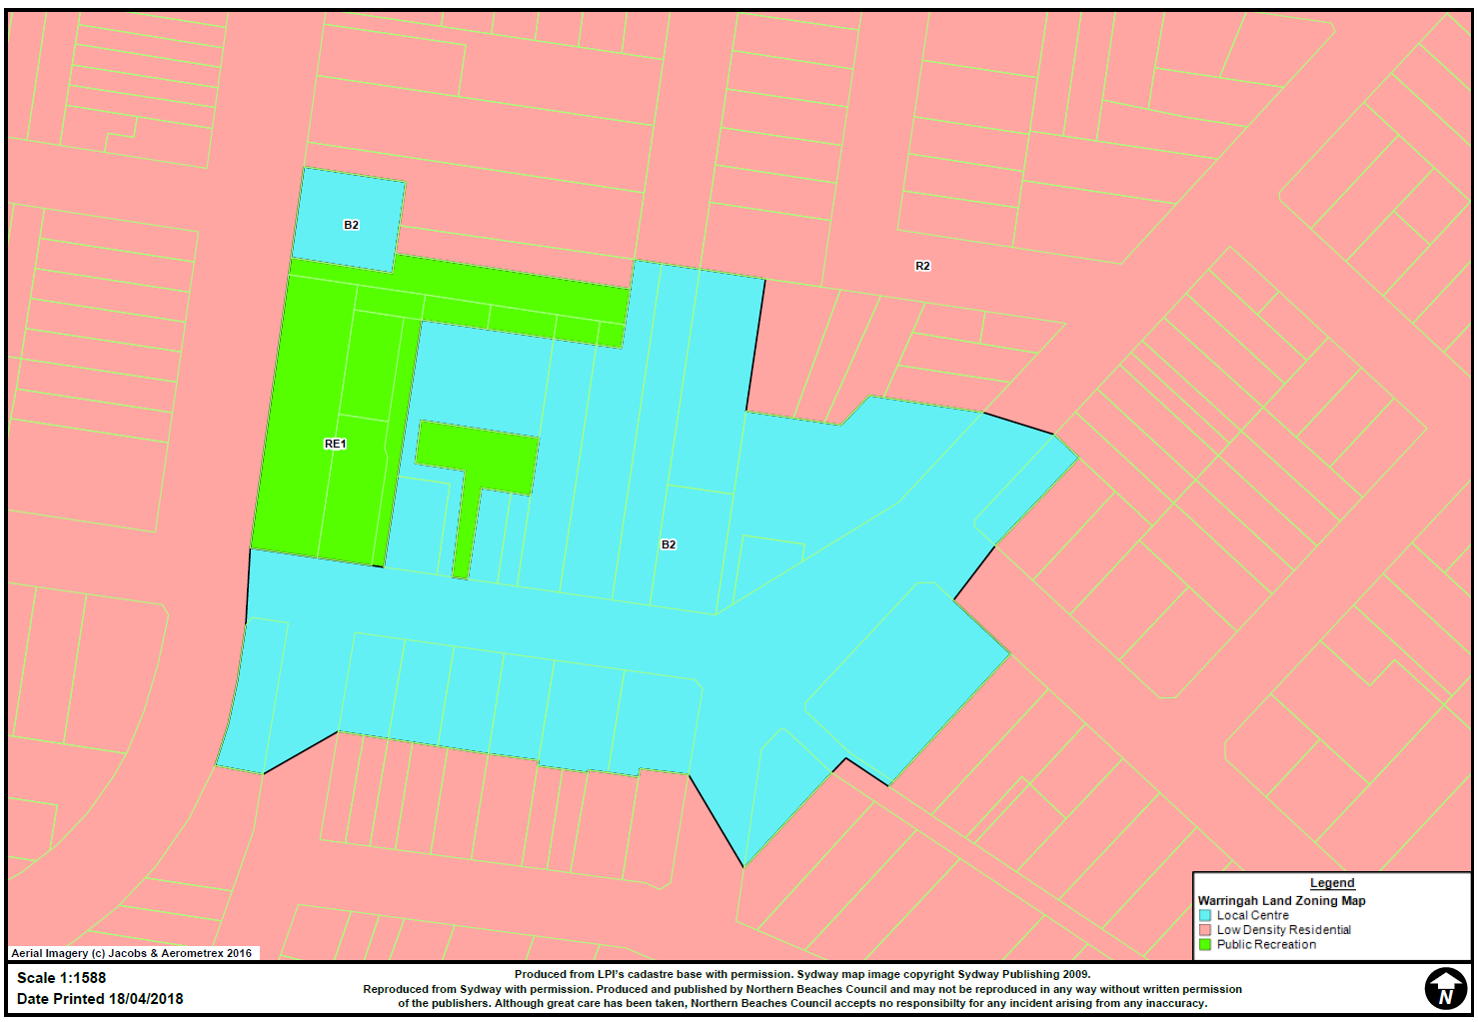
Figure 2 - Land Use Zoning
Heritage
Two items of heritage significance are located in the vicinity of the land, the Harbord Literary Institute (Item 72) and the Early Childhood Health Centre (ECHC) (Item 71). Both items are listed under Schedule 5 of WLEP 2011 and identified as being of local heritage significance (see Figure 3).

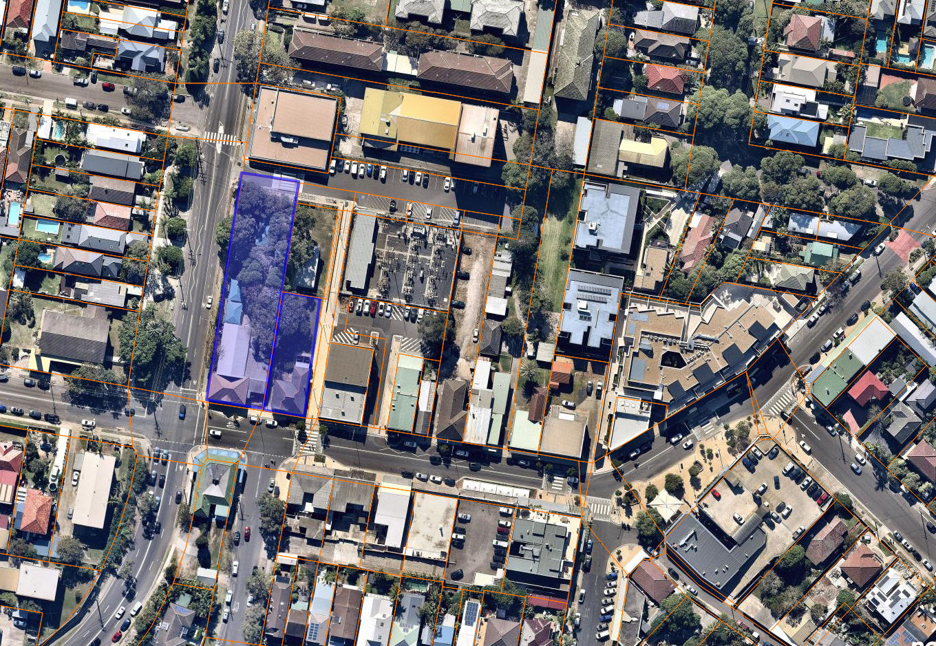
Figure 3 – Heritage items indicated in purple

Height
Currently there is no Height of Building control applicable to either carpark under WLEP2011 (Figure 4). This is also the case for the listed Heritage items (Harbord Literary Institute and Early Childhood Centre) and the adjoining Girl Guides Hall. This is characteristic of all RE1 – Public Recreation zoned land under WLEP2011.

The remainder of the Freshwater Village within the B2 zoned area has a maximum building height of 11 metres. Should the carparks be rezoned to B2 an 11 metre height limit would also apply to this land.

The residential areas surrounding the village have a maximum building height of 8.5 metres (see Figure 4).
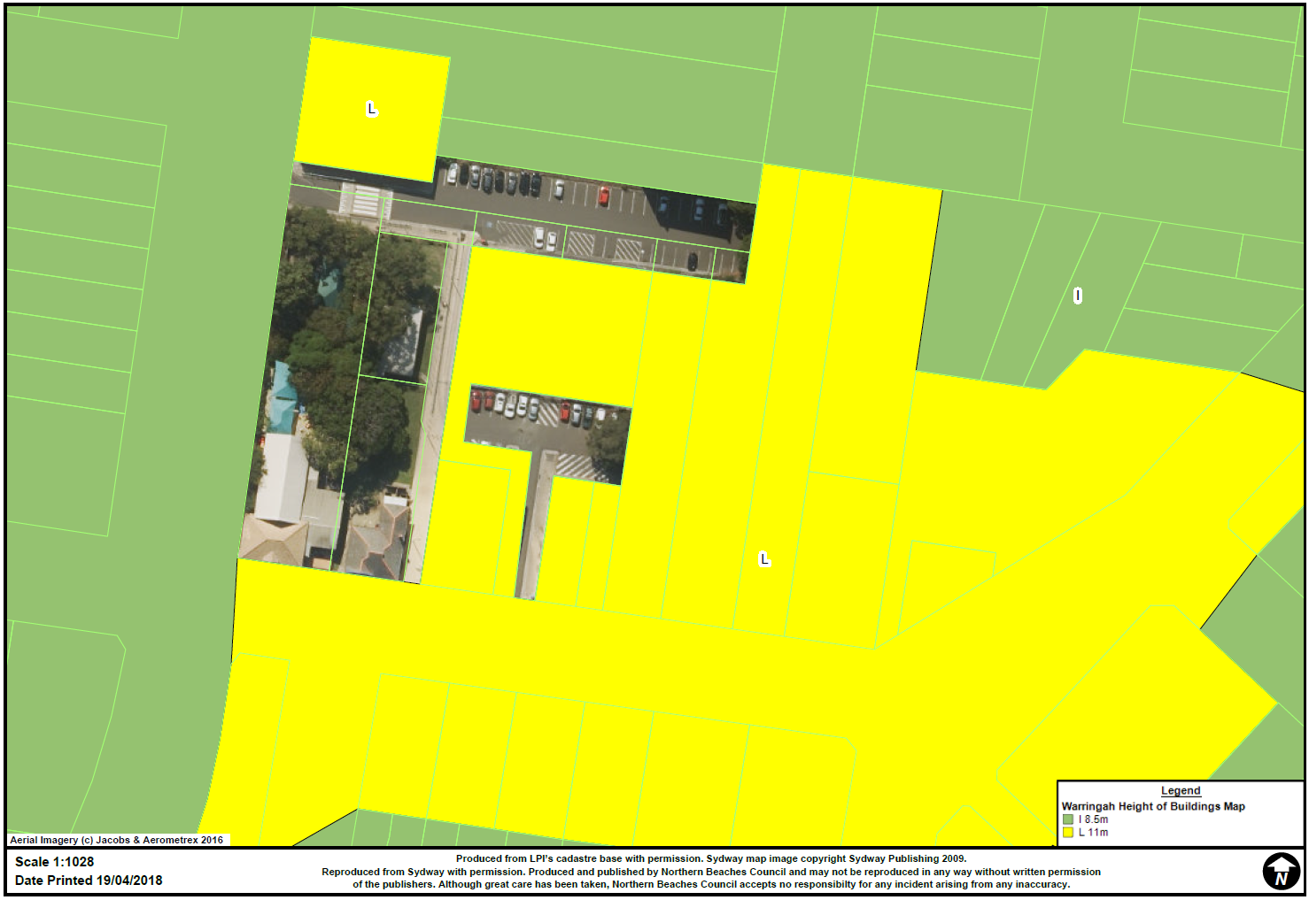
Figure 4 – Maximum Building Height

Development Control Plan (DCP)
The Freshwater DCP was adopted in May 2012. The DCP applies to the area identified as the Freshwater Village and identifies the need for an enhanced built environment and streetscape.

The DCP seeks to facilitate improved streetscape design and pedestrian / vehicular accessibility in the centre by:
- Discouraging additional vehicle access from Lawrence and Albert Streets.
- Encouraging rear and underground vehicular access for lots fronting Lawrence and Albert Streets via new connected laneways or through negotiation with Council for access via existing surface car parking areas.

The objectives and controls in the DCP further support the development of the area as a unique, vibrant and sustainable centre. Relevant objectives contained within the Freshwater DCP include:

- Reinforce and enhance the role of Freshwater Village as a centre for the local community.
- Reinforce and enhance the main street character of Lawrence Street.
- Achieve attractive, interesting and welcoming street frontages.
- Improve amenity and safety for pedestrians.
- Minimise the impact of service vehicles and loading.
- Relocate loading and servicing away from Lawrence and Albert Streets.
- Maintain uninterrupted pedestrian circulation and flow.

The achievement of positive urban design principles is a key objective of the DCP through the facilitation of rear access, removal of vehicular crossovers and access from existing Council car parks. The current classification of the car parks under the Local Government Act prohibits legal access arrangements being made and is inconsistent with the aims and objectives of the DCP.

Carpark Description and Function
Oliver Street Carpark gains vehicle access from Oliver Street, and via a one-way access from Lawrence Street Carpark. The access from Oliver Street is approximately 7 metres in width and 30 metres in length before widening to 18 metres for an additional length of 70 metres, where 41 line marked spaces are positioned on both the north and south sides.

Lawrence Street Carpark gains vehicle access from Lawrence Street. The access way is positioned between two commercial buildings and has a width of 7 metres and a length of 30 metres. There are 13 line marked car parking spaces within a rectangle shaped area which is 18 metres by 36 metres.

An Ausgrid substation is positioned on the south side of Oliver Street Carpark, which separates the two carparks (Figure 9 and 10). In addition, Ausgrid owns a portion of the access to Lawrence Street. A one way access handle approximately 3 metres wide, with an adjoining pedestrian footpath on the west side of the substation, connects both the carparks. The one way vehicular connection between the carparks is northbound, from Lawrence Street Carpark to Oliver Street Carpark. Vehicles using this connection must cross the Ausgrid-owned land.

The primary parking for Freshwater Village is street parking. Oliver Street and Lawrence Street carparks provide for overflow parking for the village and to cater for the adjoining uses, principally the Harbord Literary Institute and Early Childhood Health Centre. Limited car parking is also a feature of a number of private developments within the Freshwater Village and these uses rely on the Oliver Street and Lawrence Street car parking areas for vehicular parking. Due to the nature, size and historical development of the Freshwater Village some existing developments rely on access from these carparks for the loading and unloading of goods.

Due to the current layout, built form and historical development of the Village there are limited opportunities to provide alternative or increased car parking capacity at this time. There is a perceived lack of parking within the Freshwater Village and the removal of any car parking spaces is not considered favourably unless they are provided elsewhere.

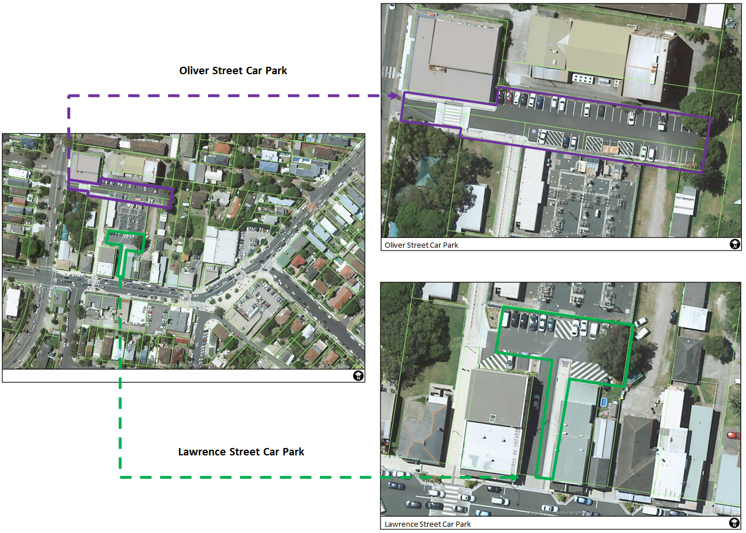
Figure 5- Carpark
Development Constraints
Agreement
On 2 February 1970 Council resolved to acquire a private parcel of land in order to extend and improve the Oliver Street car park. Acquisition was subject to conditions including that vehicular access be maintained between the carpark and an adjoining privately owned allotment, 15 Lawrence Street, at all times (Figure 6). The parcel was subsequently acquired in accordance with the approved conditions.

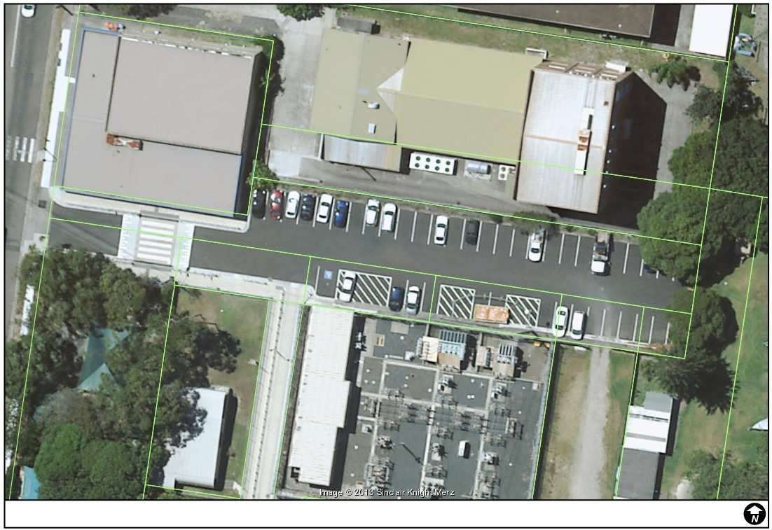
Figure 6 - Agreement with 15 Lawrence Street and Council

The agreement permits the landowner private vehicular access between the property and the Oliver Street carpark. The agreement dates back to 1970, predating the introduction of the LG Act and relates to the acquisition of a private parcel by Council as part of improvements to and expansion of the Oliver Street carpark.
Council has received legal advice that the agreement amounts to a constructive trust and Council is therefore obliged to maintain access to the carpark for the owners of 15 Lawrence Street, Freshwater. The constructive trust significantly predates the introduction of the Local Government Act 1993 which introduced the statutory classification of land owned by Council as being either community or operational land.
Informal Access
A number of private land holdings adjoining the land currently gain private access to and from the land. The informal access is a direct result of location, directly backing onto Community Land and the established built form of the Freshwater Village, prior the Local Government Act 1993 (Figure 7 and Figure 8).
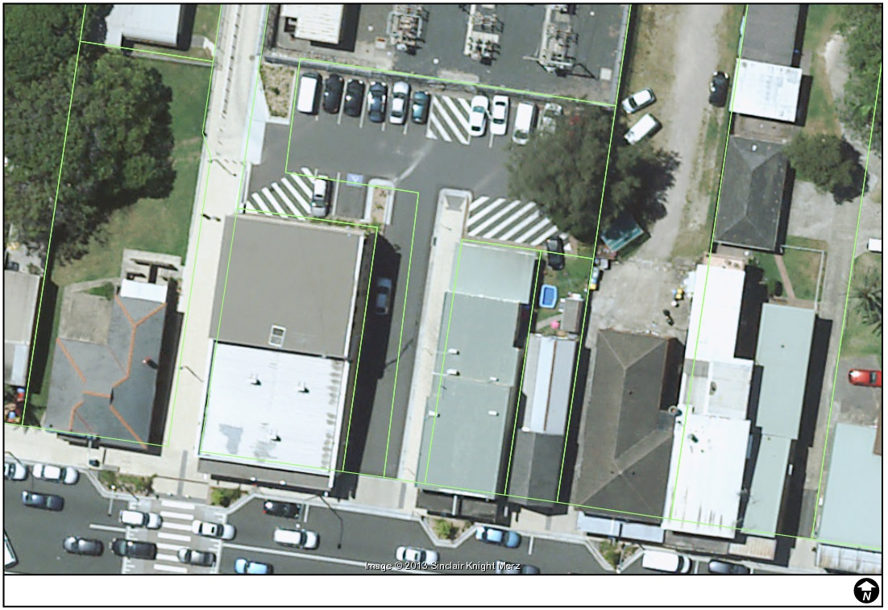
Figure 7 - Informal Access onto Lawrence Street Car Park

Figure 8 - Informal Access onto Oliver Street Car Park
The only way access can formally be permitted to these properties is through the reclassification of both the Oliver Street and Lawrence Street car parks.

Urban Design
Council aims to deliver better urban design to the village. Better urban design outcomes derive from improving pedestrian and traffic safety by minimising crossovers onto Lawrence Street. This will enhance the pedestrian and shopping environment and increase opportunity for street furniture and landscaping. This would be achieved by reclassifying Oliver Street and Lawrence Street carparks to ‘Operational Land’.

Ausgrid Substation
Ausgrid’s electricity substation is positioned between Oliver Street and Lawrence Street carparks as shown on Figure 9 and 10. The substation is a critical infrastructure site and Ausgrid has no intention on relocating. The nature of the use and the location creates a number of developmental limitations. These include:
- Underground cabling associated with the substation.
- The land use has potential for the release of Electromagnetic Radiation and contaminates.
- As an infrastructure provider any development adjoining the site would also be required to be referred to Ausgrid for comment.
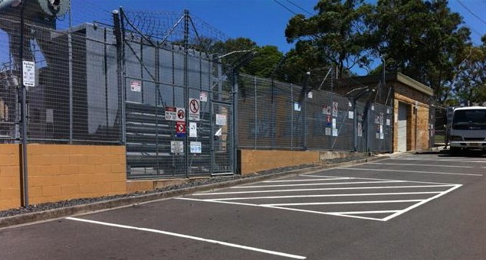
Figure 9 - Ausgrid Substation

Development Potential
The size and shape of the car parks limits their potential development. Oliver Street carpark is 1,500m² and is made up of seven parcels of land. Lawrence Street carpark is 720m² and is made up of one parcel of land. Both carparks have a narrow access handle before widening into the allocated car parking area.
The carparks and surrounding land parcels have various owners (Figure 10) as follows:

- Part of the access way to the Lawrence Street car park is owned by Ausgrid.
- Northern Beaches Council owns the parcel which makes Lawrence Street carpark, and six of the seven parcels of Oliver Street carpark. Northern Beaches Council also owns Harbord Literary Institute and Early Childhood Health Centre.
- Department of Lands owns one parcel of land from the Oliver Street carpark and the Girl Guides Hall.
- Telstra owns and operates the building directly north of Oliver Street carpark.
- The land adjacent the entrance to Oliver street carpark is owned by Mount Pritchard & District Community Club Ltd.
- The surrounding parcels are privately owned.

The ownership pattern is fragmented and there are a range of land uses in the area including community facilities, service utility providers, residential, commercial and retail. The fragmentation means that amalgamation of sites within the Freshwater Village and the achievement of a cohesive outcome may be difficult.

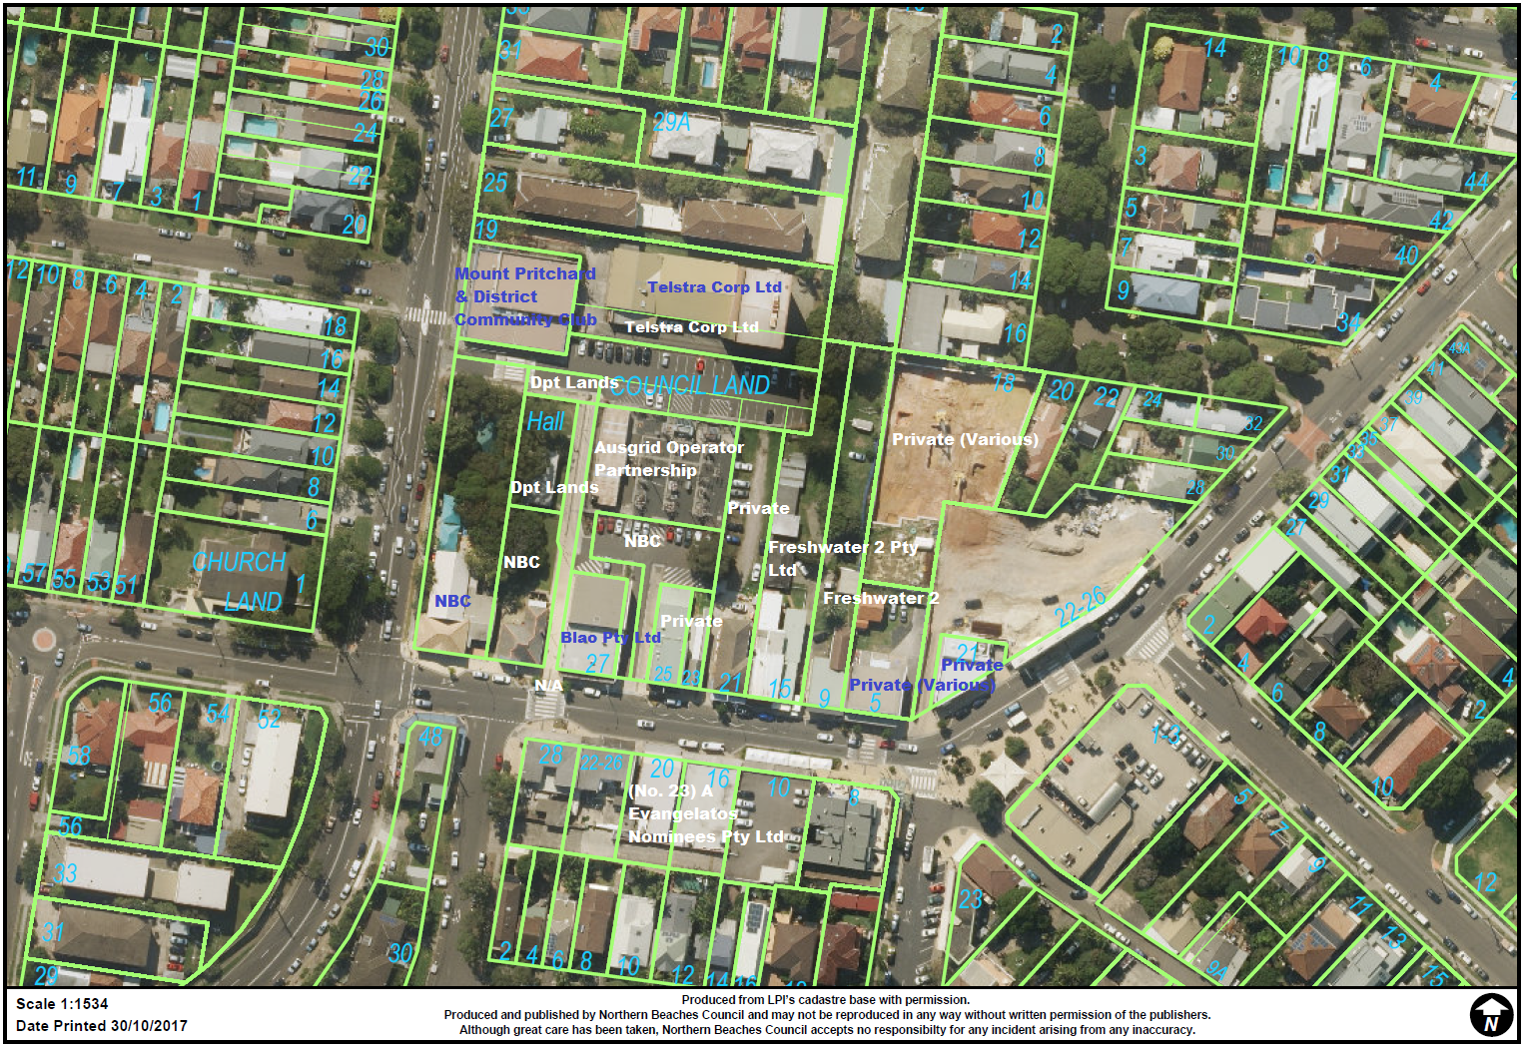
Figure 10 - Land Ownership - ownership defined by green cadastre
Development Applications
As of July 2018 there are two development proposals for the construction of shop top housing in Lawrence Street:

- DA2017/1294 has been approved for the development of shop top housing at 9-15 Lawrence Street, Freshwater. The vehicular access to the development will be gained from Lawrence Street, however a reclassification will allow for vehicular access to be gained via Oliver Street carpark.

- DA2017/1287 proposes construction of shop top housing at 21 Lawrence Street, Freshwater. There is proposed vehicular access via Oliver Street carpark, however this cannot be formalised unless there is a reclassification to Operational Land. If there is no reclassification vehicular access will be gained from Lawrence Street.

Conclusion
The current classification of the Lawrence Street and Oliver Street carparks under the Local Government Act, 1993 as “Community” land prevents Council from granting a lease or a licence to Lawrence Street land owners for rear vehicular access to their properties.
Consequently, Council cannot support development proposals for land in Lawrence Street that would remove driveway crossings in the street and replace them with rear access from the car parks. The removal of driveway crossings in Lawrence Street would significantly improve the safety and amenity of pedestrians and improve the streetscape character consistent with the objectives of the Freshwater Development Control Plan.
The current use of the land for carparks is inconsistent with the zoning of the land as RE1 Public Recreation. Council has progressively rezoned its carparks to more accurately reflect adjoining land uses. In this case the most appropriate zoning for the carparks is B2 – Local Centre, consistent with the zoning of the adjoining village.
Recommendation
It is recommended that a Planning Proposal to reclassify the Lawrence Street and Oliver Street carparks to ‘Operational Land’ and rezone both to B2 – Local Centre is prepared and submitted to Council for initial approval to proceed to the Department of Planning and Environment for a Gateway Determination.

