Community and Stakeholder Engagement Report
Addiscombe Road, Manly Vale Path Upgrade
Impact level: Four
Consultation period: 27 May to 24 June 2021

Contents
1. Summary 2
1.1. Key outcomes 2
1.2. How weengaged 3
1.3. Who responded 3
2. Background 4
3. Engagement objectives 4
4. Engagement approach 4
4.1. Reaching diverse audiences 5
5. Findings 5
Appendix 1 Verbatim community and stakeholder responses 6

Summary
This report outlines the outcomes of community and stakeholder engagement as part of a proposal to upgrade the existing unsealed shared path between Addiscombe Road and Campbell Parade in Manly Vale.
The findings show a high level of support for the proposed shared path upgrade, highlighting anticipated benefits for all path users.
Respondents who were not supportive of the proposal felt that shared paths were generally unsafe. Others expressed concerns that upgrading the path to a concrete surface would impact the natural environment.

Key outcomes
Total unique responses received | 80
How responses were received | Online comment form  Written responses (email/letter) |  | Completions: 76  Number received: 4
Online sentiment question•  Do you support the proposed shared path? | Total responses = 76
Feedback themes | Improved access and connectivity.  Path safety. | Natural environment.

How we engaged
Have Your Say | Visitors: 362 | Visits: 309 | Av. time onsite: 1m
Print media and collateral | Letterbox drop: Postcode - 2093  Site signs: Established on and around the site |  | Distribution: 252  Number: 4
Electronic direct mail (EDM) | Community Engagement (fortnightly) newsletter: 2 editions  Council (weekly) e-News: 1 edition |  | Distribution: 20,000 subscribers  Distribution: 150,000 subscribers

Who responded
Gender
Age group(s)
Postcode(s)

Background
Our Move – Northern Beaches Transport Strategy in 2019 identified how we can encourage active travel to help break the reliance on cars as the main way we travel across our area.
Shared paths are one way we can achieve this while also providing opportunities for both transport and recreational benefits and promoting a healthy lifestyle through active travel.
The project is funded through the Federal Stimulus - School Infrastructure Program to develop safer pedestrian and bicycle routes in the vicinity of schools across the Northern Beaches.
In 2020, an Interim Site Management Plan (ASMP) was developed for Addiscombe Road, Manly Vale which identified concreting the path as a measure to help contain contaminated soils and protect path users.
The existing dirt path connects all path users between Addiscombe Road and Campbell Parade, Manly Vale.
A proposed concept plan to upgrade the path to a concrete surface was presented to the community and identified as an opportunity to provide safer and more accessible pedestrian and bicycle connection to Mackellar Girls Campus and surrounding areas.
The project’s impact level four and a Community and Stakeholder Engagement Plan was devised on a single stage approach.

Engagement objectives
Community and stakeholder engagement aimed to:

- provide accessible information so community and stakeholders can participate in a meaningful way
- identify community and stakeholder concerns, local knowledge and values
- seek out and facilitate the involvement of those affected by or interested in a project.

Engagement approach
Community and stakeholder engagement for the Addiscombe Road, Manly Vale Path Upgrade was conducted over a four week period, from Thursday 27 May to Thursday 24 June 2021.
The engagement was planned, implemented and reported in accordance with Council’s Community Engagement Matrix (2017).
A project page was established on our have your say platform with information provided in an accessible and easy to read format.
The project was primarily promoted through our regular email newsletter (EDM) channels.
Feedback was captured through an online comment form embedded onto the have your say project page. The form included a question that directly asked respondents for their level of support on the proposal.
An open-field comments box provided community members a space to explain or elaborate on their support, not support or neutral sentiment as well as any other feedback they wished to contribute.

Reaching diverse audiences
A thorough stakeholder mapping exercised was completed to identify and understand the needs of the whole community.

It was determined for this project that it was particularly important to hear from local schools and residents living in the surrounding area.

Findings
The findings show a high level of support for the proposed shared path upgrade.

The majority (86 percent) on responses were supportive of the proposed upgrades to the path in Addiscombe Road. Most agreed that the anticipated benefits to access and connectivity for people walking and riding bikes in the local area was beneficial to the local community.

Respondents who were not supportive of the proposal raised safety and environmental concerns. Table 1 provides a full breakdown of issues raised.
Table 1: Issues raised in responses received (qualitative data)
Theme | What we heard | Council’s response
Path safety | Concern that shared paths are dangerous or uncomfortable for pedestrians due to shared use with people riding bicycles. | Transport for NSW Centre for Road Safety released a discussion paper on shared paths in 2015. The concluding remarks, based on evidence, stated that shared paths represent a relatively low safety risk.  The shared path has been designed to be as safe as possible.
Natural environment | Some respondents felt that upgrading the path to concrete would spoil the natural environment. | Due to the sites previous use as an incineration site, it has been classified as contaminated land.  The path works will protect the public from coming into contact with contaminated substances on the current unsealed path surface.  Concreting of the path was identified as an immediate management action within the Addisombe Road, Manly Vale Interim Site Management Plan 2020.  Sealing the path with concrete will help contain contaminated soils and protect path users.

Appendix 1 Verbatim community and stakeholder responses∗

Number# | Comment
1 | I am a local . There are very few places where areas are not built up with concrete . Since the pandemic we are more aware of the importance of being in touch with nature . Having your feet close to the earth . There is enough research to suggest the same . In the botanical gardens they ask you to walk-in the lawn. Why don’t you lay a granite path open for cyclists , wheelchairs and the likes . During flooding a few times a year the debris from a lifted concrete path is only more works fir the council . Please leave us with one path not concreted
2 | not keen on cyclists approaching pedestrians from behind, will there be alert signs / mirrors along the path? cyclists are reluctant to stop , and amblers are unpredictable often straying across the path to view flora and fauna, or pick up litter or recyclable containers.
3 | My position is no to shared paths due conflict,but they are better than nothing.The real solution  is separate bike ways but I realize, that is in this world, utopian
4 | Please continue this the concrete pathway, I never understood why it suddenly stops
5 | The proposed shared path will significantly increase the safety of active transport through the area. This section forms part of a route between the Manly and Brookvale areas which is completely off-road and minimises hills. As such, it should be made as safe as possible. To this end, please ensure that there is adequate lighting for night use. For Stage 2, it would be far better to have the alignment completely to the East of Addiscombe Road, so users are not required to cross the road.
6 | Yay no more punctures here! Thanks
7 | Great idea. We need more pathways for exercise - wheelchairs, prams and bikes.
8 | I use this route on my bike 2-3 times a week I’m a 71 year old lady and anything to make cycling safer for all has my endorsement.
9 | Great idea. Would be amazing if we could also get just one single path in Quinlan Parade Manly Vale TOO... so LONG overdue too
10 | A very worthwhile addition to the local cycle network
11 | Addiscombe road leading up to the bike path is quite dangerous, particularly on sports days when cars speed along there, then up Innes Rd and down Quirk rd to get to Passmore Reserve. Could you please change this whole area to 40km speed limit so that it is not so dangerous?  Thank you!
12 | Improving active transport to school and sports fields is great investment and this is a popular route. Well done to all involved in securing the funding.
13 | Great
14 | I use this path almost every day on my bike.  It c an be dangerous in several places and also cause damage to the bikes tyres.  The sealed shared path will be an EXCELLENT improvement to this well used route between playing fields and the school, aquatic centre and general pedestrian traffic.
15 | It will be an excellent addition to the area and will be used even more frequently than it already is used.  It is very dark at night through there, is any lighting on the plan?
16 | …I regularly ride that path with my bike. The path itself is great. I don’t think the fact it is un-paved it is dangerous. I argue the other section (what is part of stage 2) is the section which is currently dangerous to ride because it is vaguely shared with the main road, and it should be addressed first.
17 | Shared paths dont work. Cyclists get blamed for every incident unfairly. Shared paths for kids supervised by parents ok, but for the majority of adult cyclists they are a disaster. There should be seperated bike paths unavailable to pedestrians, runners or any electric vehicle.
18 | It essential we build better inter connecting cycle-ways.
19 | Whilst challenging path should Be seperate
20 | That will be helpful thanks.
21 | I think that shared paths are a disaster wherever they are. You've even made a video that shows exactly what happens most of the time. The worst shared path is the one from Manly to Shelly beach with some cyclists totally ignoring the 'no cycles' ban on Saturdays and Sundays. Please invest a bit more money and separate the people on wheels from the people on foot. I'm an 'older Australian' but pretty fit, but find that while many cyclists are polite, far more cyclists and skateboarders are not. They are also quiet and I worry about stepping round a dog and walking straight into a bike. I do not wish this message to be publicly available.
22 | This upgrade will greatly improve cycling and pedestrian access to/from the Mackellar school and the surrounding residential area. We are local residents and use this path, when conditions allow, to visit the Manly aquatic centre and the beach on both cycle and foot, thereby avoiding using the car for transport.
23 | Great Idea and some landscaping wouldn't go astray.
24 | To whom it may concern,  I use the ‘bush track’ between Addiscombe rd and Campbell parade every week day to walk my dog, and on weekends with my family.  As a local, I fully support concreting the existing dirt path to contain the contaminated soil and debris that sits on the surface.  However, I feel the project scope needs to also include a rubbish bin next to the dog bag stand at the Addiscombe st end.  Undoubtedly this new path will attract more users and with more users comes more rubbish. Already, the path is littered with plastic bags from eager duck feeders, poo bags from lazy dog walkers and food containers from tossers.  The planting and restoration of native vegetation along this path over the past few years has been truly wonderful. I urge you to keep the beautification process moving forwards by installing a bin too.  Kind regards,  Emma
25 | .
26 | use this path regularly but it is often extremely muddy
27 | Excellent idea. More cycling paths the better
28 | This has been a long time coming and it is so good to see that this area of Manly Vale is getting some attention. The path will provide a missing link in the shared path to Manly, and also expose this area to more people to see how neglected and forgotten this site has been. Living just around the corner from this site for the last 30 years, I was hopeful that my children may have been able to play in this area, as it was destined for remediation. However they are now all young adults. I now hope that more than a path will be constructed in this site and that the next step is full remediation. Maybe my future grand children will be able to play there.
29 | This upgrade is greatly needed. The present track is narrow, has a loose surface in places and is subject to flooding after rain. Several friends and my wife and I regularly use this track as a link between two sets of cycleways . We often meet young mums pushing prams and strollers on this track and it is very narrow. Congratulations on the proposal. Can't wait.
30 | 1. I support this.  2. Please also progress Stage 2.  3. MOST IMPORTANT  a) Extend Stage 2, on the western side of Addiscombe Rd, all the way to Kenneth Rd, and install a new crossing across Kenneth to link to Kenneth Rd cycle path. (coloured red on attached image)  c) Undo the existing path and crossing at southern end of Addiscombe (coloured blue on attached image).  REASON: the existing path is dangerous - northbound cyclists suddenly join traffic, contra-flow, from a position obscured by vegetation.
31 | Shared paths are dangerous for the elderly, cyclist seem to think they have the right of way, they travel too fast for elderly or disabled people to move out of their way. most travel too fast for the area.
32 | I hope this will also address the flood plain at the Campbell parade end of the path which floods every time it rains.
33 | I was looking for this upgrade for many years. I walk almost everyday on this path and it is hard to walk also riding bike is hard. I am hghly supporting the development. I wish it could be wooden board instead of concrete. That would be nicely blending with the surrounding nature.
34 | It would be better to have the path for the walkers and the bicycles separated to avoid collisions and allow for higher speed bicycles traffic. This will make the path more functional for all users.
35 | This missing link is well used as can be seen by the worn path across the grass etc where the path is proposed. The existing dirt/grass section is dangerous when it is wet.
36 | I would definitely like to see the rough unsurfaced path covered with a best-practice concrete shared path. I look forward to the works getting underway as soon as possible.
37 | The pathway should be shared and the faster the bicycle traffic can get through on this path the less they have to withstand from the stench from the creek and Manly Lagoon.  However, how about changing the side where pedestrians walk to the opposite side of the bicycles so that pedestrians do not have to worry about bicycles approaching from their rear (and generally at speed given the electrification of bikes, scooted and skate boards) on the same side as they are walking on. We are supposed to do this when walking on the roadway when it is a shared pathway so why is it planned differently here?
38 | this is great - I use this link on my bike but it's rough on the equipment and slow, so really looking forward to a proper path along here. It's a shame phase 2 works mean having to cross the road but it's better than nothing
39 | Great idea - very supportive
40 | This is a valuable community upgrade. Is an extension into a pedestrian crossing over Kenneth road being considered? This is a main road, frequently used by families to access swimming pool, Graham’s reserve and as noted in the plan McKellar girls - it seems like a great opportunity to extend the shared path into safe pedestrian crossing at the junction of Addiscombe and Kenneth. I also wonder why there is not already a crossing further down by the pool near Francis Street?
41 | The proposed shared path at the Kenneth Road end should NOT be on the opposite side, requiring cyclists and pedestrians to cross often busy Addiscombe Road. Please dont say its just too hard.
42 | Make it wider so there’s less confrontation between riders and walkers.  This area should also be the site of a pocket bike park with jumps and pump track.
43 | As an older pedestrian I fear that mixing pedeststrians and bicycles is dangerous.
44 | I support the proposal, it is a quick access route towards manly that avoids traffic and would be preferable to have a sealed path for bikes.
45 | Would be great to get some lighting upon the path, for in winter after work hours it is often dark which is troubling for cyclists. Think it is a great initiative though, particularly so if we keep in mind the drainage issues at the lowest point of the path.
46 | The current path is not very inviting to a wide range of potential users. These improvements look sensible and I look forward to cycling there.
47 | I support more bike and shared paths in NBC.
48 | I am very pleased that this pathway is being sealed. It is a useful accessway that is flat and avoids nearby hills - which makes it great for cycling. I hope it can be extended to Kenneth Rd, to join up with the pathway currently along Kenneth Road Addiscombe Road is dangerous to ride along as the shoulder is very narrow in places.  This will make the pathway suitable to use after rain. It will benefit people travelling by bike from Balgowlah to Brookvale and will also benefit Mackellar Girls campus.
49 | This will encourage cycling for students at Mackeller Girls High, less motorised traffic and increased safety. Wiil also link up with the existing cycleway on Campbell Pde. gaining access for cyclists and walkers to the numerous sporting facilities in the are such as the swim centre, LM Graham Reserve, and golf club. Please do it!
50 | I support any improvement in cycle ways - I would consider cycling way much more if I felt safer, and if the cycling paths felt more 'connected' and integrated... rather than the fragmented and often confusing state I feel it currently is in.  If the budgets are not there to concrete them, I am sure that widening, smoothing and regularly maintaining the natural pathways through and alongside the bush will also highly benefit the community - with consistent and visible signage included. Signage that can also be seen from a distance so one can prepare for the anticipated turns etc.  Please consider to make the paths wide enough to accommodate the growing interest in cycling. Not just for today but imagine a few years from now.  If you create the infrastructure in a very user friendly way, many many more people will flock to it. Be ready for it! :)
51 | Paths shared by walkers and cyclists do not work. Cyclists already make walking around Narrabeen Lake a nightmare. Far too many cyclists travel too fast and delight in scattering walkers. I object having to be on the alert for them rather than enjoying the we. They need their own speedway, not taking over walking paths.
52
53 | Supports bicycle riding
54 | I’m all for additional cycling infrastructure, but I actually like that bit as a dirt path.
55 | I’m sure you know already but this path is not usable after heavy rain due to deep puddles. It is great news to hear you will be fixing this!!
56 | As this will impact Mackellar Girls Campus, any work that needs to be completed outside the school must take place during school holidays. The Campbell Parade area is very busy, it has significant bus bays an many parents drop and pick up their daughters.
57 | Getting your citizens moving and reducing driving is a must, for physical health, mental health & increased social interaction & cohesion.
58 | An excellent idea and long overdue. I hope the depression near the Campbell Parade end is filled in to avoid the pooling of water after heavy rain
59 | Excellent proposal. This will help my daughters get to school.
60 | This path links to the Seaforth-Manly Cycle path and provides a safe (and flat!) route through to Campbell Parade , and onward, across the creek to the path to Kentwell Rd.
61 | I ride on this path quite regularly - going from my home in Manly Vale to the pool or the beach or Manly Central - but have to avoid it after rain because it gets quite muddy. It would be great if it were paved.
62 | About time
63 | Fantastic! I cycle this route regularly between home in North Balgowlah and Freshwater Beach.
64 | Very often Mums with twin prams are struggling on the dirt path. Tha community will really embrace this upgrade.  Many thanks  Deirdre O'Dea
65 | 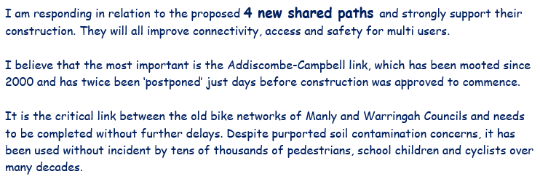
66 | 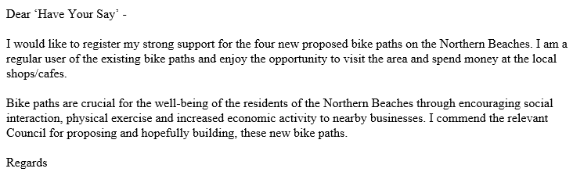
67 | 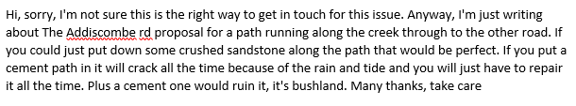
68 | 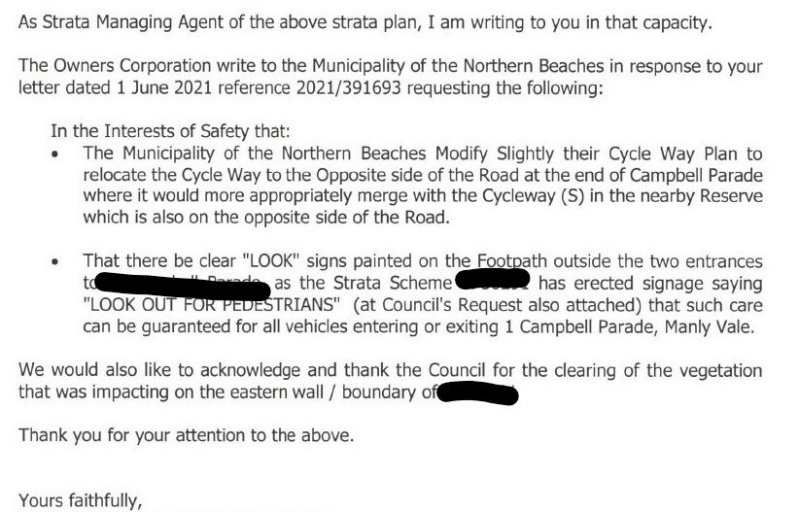

Document administration
Version | 2.0
Date | 8 September 2021
Status | Final
Related Projects | Northern Beaches Bike Plan
Notes | Community and stakeholder views contained in this report do not necessarily reflect the views of the Northern Beaches Council or indicate a commitment to a particular course of action.

• Written responses did not respond directly to the online sentiment question
Demographic data was gathered by request only. The data represented only includes those respondents who provided this detail.
∗Personal details and inappropriate language have been redacted where possible. Spelling and grammatical errors have been amended only where misinterpretation or offence may be caused.
# 64 online responses provided feedback in addition to the mandatory sentiment question.

