Option 1b:
Extension to the existing commuter wharf through the addition of additional curved arm
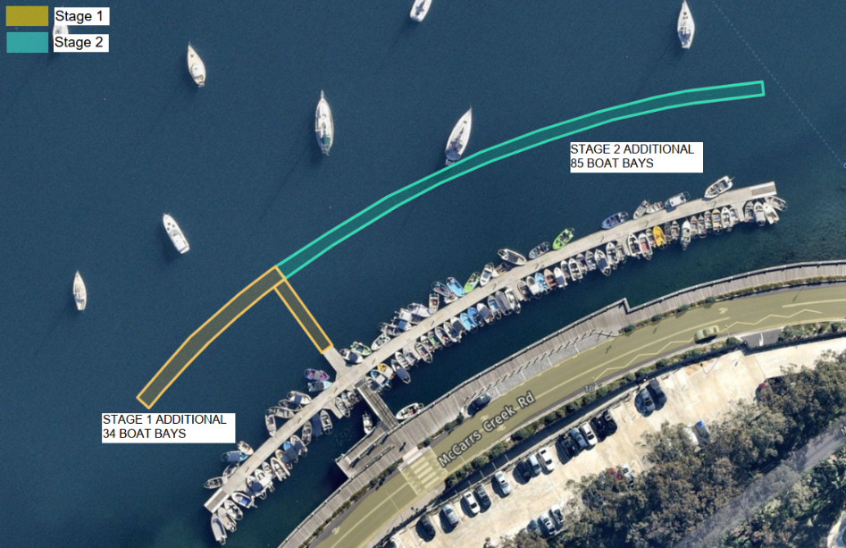
Criteria | Description | Score
Environmental | Minimal potential environmental impacts | 8
Additional Boat Berths | Current number of boat berths at Church Point Commuter Wharf – 111  Additional boat berths by means of extending the existing structure – 119  Total - 230 | 9
Cost | $9,443/berth | 10
Accessibility | Convenient | 10
Coastal Processes | Relocation of swing moorings would be required, which may take a long time. | 6
Community | TfNSW do not support this option as Option 1b would impose/obstruct on the existing navigation channel used by barge operators to the cargo wharf. | 5
RANKING |  | 2nd

Option 2a
Additional Structure at Rostrevor Reserve
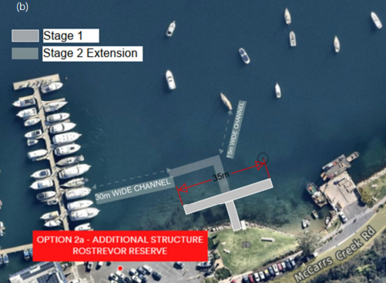
Criteria | Description | Score
Environmental | Minimal potential environmental impacts | 8
Additional Boat Berths | Current number of boat berths at Church Point Commuter Wharf – 111  Additional boat berths by means of building a structure at Rostrevor Reserve  Stage 1: 32  Stage 2: 25  Total – 168 | 8
Cost | $14,320/berth | 7
Accessibility | Convenient | 10
Coastal Processes | Larger boats navigating to Holmeport Marina may be impacted if the full stage 2 wharf structure was to proceed; if only stage 1 proceeded navigational issues between the cargo wharf and Marina may be avoided. | 10
Community | It was noted by stakeholders that when the temporary wharf was in place there were limited impacts to cargo wharf operations.  This is Transport for NSW’s preferred option. | 6
RANKING |  | 1st

Option 2b
Additional Structure at Church Point Reserve
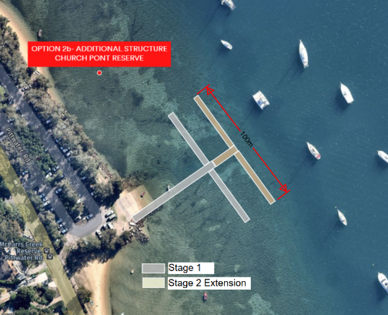
Criteria | Description | Score
Environmental | The environmental assessment has identified expansive beds of Posidonia and smaller areas of Zostera seagrass in the vicinity of the proposed additional structure.  Construction in this area will most likely impact directly on aquatic vegetation. | 7.5
Additional Boat Berths | Current number of boat berths at Church Point Commuter Wharf – 111  Additional boat berths by means of building a structure at Church Point Reserve  Stage 1: 90  Stage 2: 90  Total - 291 | 10
Cost | $10,020/berth  If this option were to be preferred, further consideration should be given to the cost associated with ongoing maintenance dredging if sedimentation were to be an issue. An indicative rate of $20/m3 with a mobilisation/demobilisation of approximately $200,000. These rates are based on assuming the dredged material is free from Acid Sulphate Soils and could be reused locally. | 8
Accessibility | Convenient | 10
Coastal Processes | Exceeds criteria for ‘moderate’ wave climate  Sedimentation | 5
Community | Following stakeholder consultation this option has been deemed unlikely to proceed due to the potential impact to aquatic vegetation. | 4
RANKING |  | 4th

Option 3a
Additional Structure at Rowland Reserve
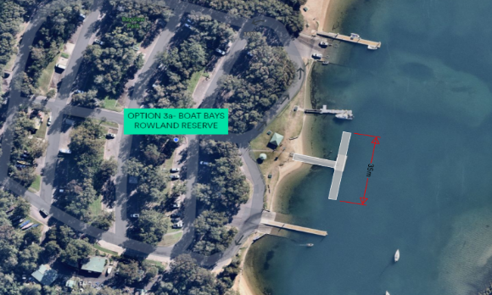
Criteria | Description | Score
Environmental | Areas of aquatic vegetation and coastal wetlands are located at or in the vicinity of Option 3a | 7.5
Additional Boat Berths | Current number of boat berths at Church Point Commuter Wharf – 111  Additional boat berths by means of building a structure at Rowland Reserve - 32  Total - 143 | 6
Cost | $20,117/berth | 6
Accessibility | Not Convenient  As this option is located 3.5km from Scotland Island it would not be convenient for offshore residents, particularly in bad weather | 6
Coastal Processes | Navigational access would be slow due to the 4 knot zones between Rowlands and offshore and the narrow access channel could be difficult to navigate. | 6
Community | Some stakeholders expressed a preference for the development of an option away from the main Church Point area due to the existing parking and traffic issues at Church Point | 5
RANKING |  | 5th

Option 3b
Additional Structure at McCarrs Creek Reserve
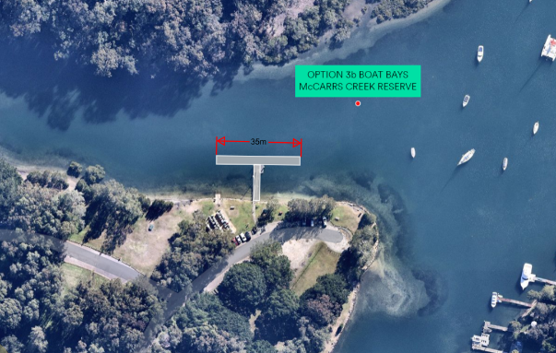
Criteria | Description | Score
Environmental | Areas of aquatic vegetation and coastal wetlands are located at or in the vicinity of Option 3a | 8
Additional Boat Berths | Current number of boat berths at Church Point Commuter Wharf – 111  Additional boat berths by means of building a structure at McCarrs Creek Reserve - 32  Total - 143 | 6
Cost | $20,117/berth | 6
Accessibility | Not Convenient | 5
Coastal Processes | Option 3b could be subject to significant tidal and/or flood currents from McCarrs Creek. There is also the potential that ongoing maintenance dredging would be required.  Navigation to this location would be difficult with no designated navigation channel. | 4
Community | - Limited access to public transport  - Limited infrastructure – additional lighting and public footpaths would be required  - Long distance from Scotland Island, including through areas harder to navigate which could present issues, especially at night.  - Long distance to drive to wharf location | 3
RANKING |  | 7th

Option 3c
Additional Structure at Bayview Baths
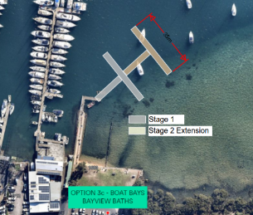

Criteria | Description | Score
Environmental | Potential impact to aquatic vegetation and coastal wetland | 8
Additional Boat Berths | Current number of boat berths at Church Point Commuter Wharf – 111  Additional boat berths by means of building a structure at Bayview Baths - 32  Total - 143 | 6
Cost | $20,117/berth | 6
Accessibility | Not Convenient | 6
Coastal Processes | Dredging of the large sandbank will be required in order to allow safe access to berths. Ongoing maintenance dredging is anticipated due to encroachment of the adjacent large sandbank.  Exposure to northerly seas | 4
Community | Stakeholders noted that location has major existing issues with parking and as a result was not considered a viable option. | 3
RANKING |  | 6th

Option 4
Combination of Stage 1 of Option 1b and 2a
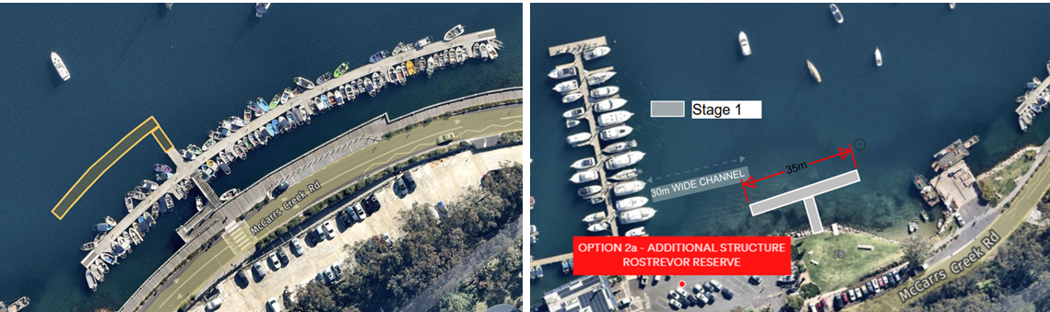

Criteria | Description | Score
Environmental | Minimal potential environmental impacts | 8
Additional Boat Berths | Current number of boat berths at Church Point Commuter Wharf – 111  Additional boat berths by means of building stage 1 of Option 1b and Option 2a - 66  Total - 177 | 7
Cost | $9,602/berth | 9
Accessibility | Convenient | 10
Coastal Processes | Relocation of swing moorings would be required for stage 1 of option 1b, which may take a long time. | 7.5
Community | TfNSW do not support this option as a staged approach as detailed in option 4 would result in a reduction of the navigation channel as in option 1b regardless of the lesser footprint. | 6*
RANKING |  | 3rd

Option | Assessment Criteria and Score |  |  |  |  |  |  |  |  |  | Score |  | Rank
 | Environmental | Boat Berths | Parking | Accessibility | Transport | Coastal Processes | Planning Approvals | Cost | Community
Option 1b | 8 | 9 | 10 | 10 | 10 | 6 | 10 | 10 | 5 | 78/90 |  | 2
Option 2a | 8 | 8 | 10 | 10 | 10 | 10 | 10 | 7 | 6 | 79/90 |  | 1
Option 2b | 7.5 | 10 | 10 | 10 | 10 | 5 | 10 | 8 | 4 | 74.5/90 |  | 4
Option 3a | 7.5 | 6 | 10 | 6 | 10 | 6 | 10 | 6 | 5 | 66.5/90 |  | 5
Option 3b | 8 | 6 | 10 | 5 | 10 | 4 | 10 | 6 | 3 | 62/90 |  | 7
Option 3c | 8 | 6 | 10 | 6 | 10 | 4 | 10 | 6 | 3 | 63/90 |  | 6
Option 4 | 8 | 7 | 10 | 10 | 10 | 7.5 | 10 | 9 | 6* | 77.5/90 |  | 3
* This option was not assessed during the stakeholder engagement however the community score for Options 1b and 2a has been adopted.

